**WEEK 3**

**CODE**

create database bank_database;

use bank_database;

create table branch(

branch_name varchar(40) primary key,

branch_city varchar(40),

assets int

);

create table bank_account(

acc_no int,

branch_name varchar(40),

balance int,

primary key(acc_no,branch_name),

foreign key(branch_name)references branch(branch_name)

on delete cascade);

create table bank_customer(

customer_name varchar(30) primary key,

customer_city varchar(40),

customer_street varchar(50)

);

create table depositer(

customer_name varchar(30),

acc_no int,

primary key(customer_name,acc_no),

foreign key(acc_no) references bank_account(acc_no),

foreign key(customer_name) references bank_customer(customer_name)

on delete cascade);

create table loan(

branch_name varchar(30),

loan_number int primary key,

amount int,

foreign key(branch_name) references branch(branch_name)

on delete cascade);

insert into branch

values('HDFC_Chamrajpet','Bengaluru',50000),('HDFC_AnandRaoCircle','Bengaluru',10000),('HDFC_ShivajiRoad','Mumbai',20000),('HDFC_ParliamentRoad','Delhi',10000),('HDFC_Jantarmantar','Delhi',20000);

insert into bank_account

values(1,'HDFC_Chamrajpet',2000),(2,'HDFC_AnandRaoCircle',5000),(3,'HDFC_ShivajiRoad',6000),(4,'HDFC_ParliamentRoad',9000),(5,'HDFC_Jantarmantar',8000),(6,'HDFC_ShivajiRoad',4000),(8,'HDFC_AnandRaoCircle',4000),(9,'HDFC_ParliamentRoad',3000),(10,'HDFC_AnandRaoCircle',5000),(11,'HDFC_Jantarmantar',2000);

insert into bank_customer

values('Avinash','Bull_Temple_Road','Bangalore'),('Dinesh','Bannergatta_Road','Bangalore'),('Mohan','NationalCollege_Road','Bangalore'),('Nikil','Akbar_Road','Delhi'),('Ravi','Prithviraj_Road','Delhi');

insert into depositer

values('Avinash',1),('Dinesh',2),('Nikil',4),('Ravi',5),('Avinash',8),('Nikil',9),('Dinesh',10),('Nikil',11);

insert into loan

values('HDFC_Chamrajpet',1,1000),('HDFC_AnandRaoCircle',2,2000),('HDFC_ShivajiRoad',3,3000),('HDFC_ParliamentRoad',4,4000),('HDFC_Jantarmantar',5,5000);

**QUERY 1**  
Display the branch name and assets from all branches in lakhs of rupees and rename  
the assets column to 'assets in lakhs'.

create or replace view custom_view (branch_name,assets_in_lakhs)

as select branch_name,assets/100000

from branch;

select* from custom_view;

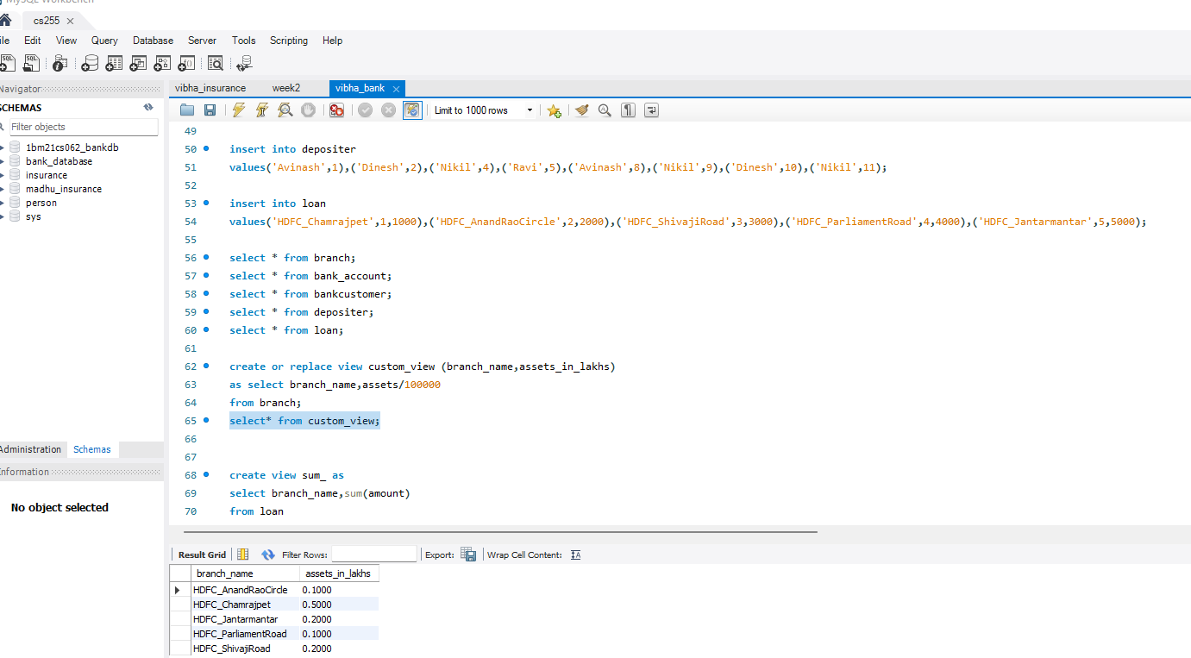

**QUERY 3**

Create a view which gives each branch the sum of the  
amount of all the loans at the branch.

insert into loan

values('HDFC_Chamrajpet',6,6000);

create view sum_ as

select branch_name,sum(amount)

from loan

group by branch_name;

select* from sum_;

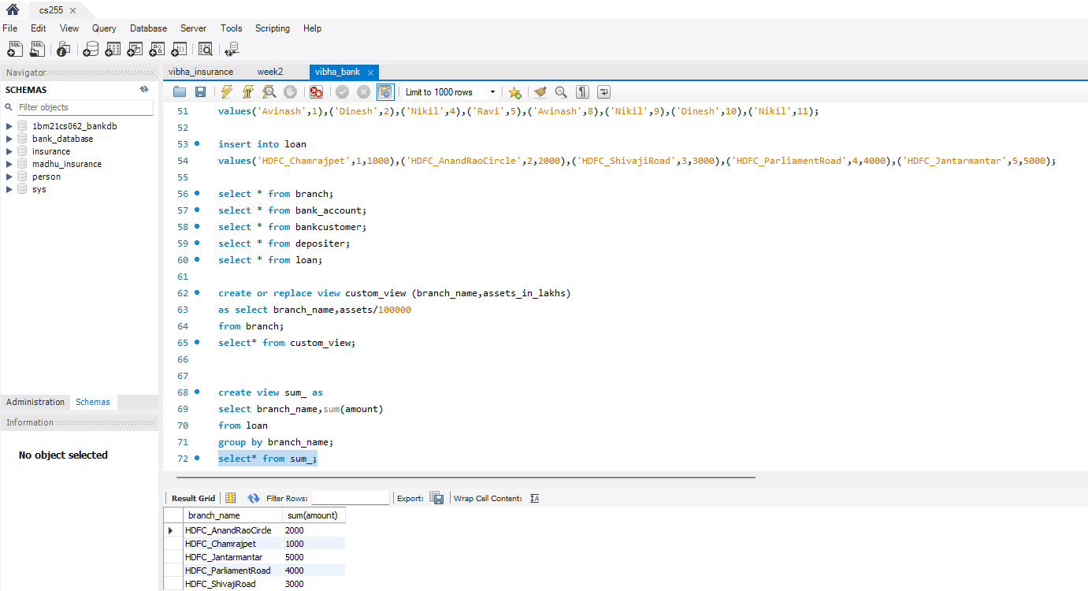

**QUERY 2**Find all the customers who have at least two accounts at the same branch (ex.  
SBI_ResidencyRoad).

select customer_name, branch_name from depositer d

inner join bank_account b on d.acc_no=b.acc_no

group by customer_name, branch_name

having count(*)>=2;

